HTML TAGS

!**DOCTYPE html :** The <!DOCTYPE> declaration informs the browser that the document is written in HTML5, which is the current standard for web development.

**lang in html tag :** for language.

**<head> :** The <head> tag in an HTML document contains metadata and links to resources that are not displayed directly on the web page. It provides essential information about the document and instructions for the browser.

**The <meta charset>** tag in HTML specifies the character encoding used by the webpage. It ensures that the text content is displayed correctly in the browser, especially for characters outside the standard English alphabet (e.g., accented letters, symbols, or characters in non-Latin scripts like Chinese, Arabic, or Cyrillic).

**<!—text-->** : to add command line.

**<title> :** The <title> tag in HTML defines the title of a webpage.

**<body> :** The <body> tag in HTML defines the main content area of a webpage that is displayed to users in the browser. It acts as a container for all the visible elements and interactive content of the page.

<**h1>…<h6>** : for heading.

**<p> :**  for paragraph .

**<HR>** : To add a horizontal line.

**<BR> :** to add go next line.

# HTML Block-level Elements :

Block-level elements start on a new line, and anything that follows them appears on the next line. These elements may contain margins to add some space before and after. These elements take up the full width of their parent elements by default; you may set their width by using the CSS width property.

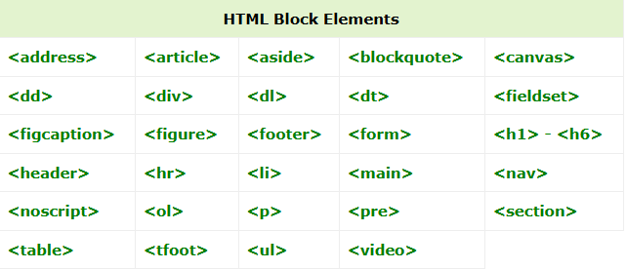

# HTML Inline Elements

Inline elements can appear within the same line and do not start a new line on their own.

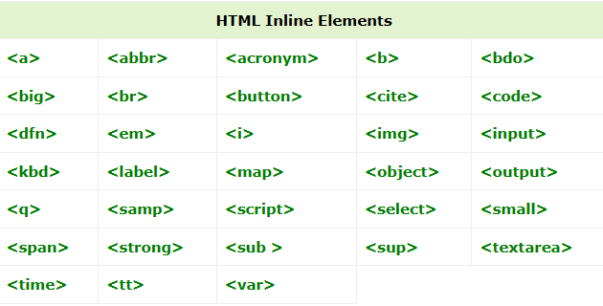

**<em> :** The <em> tag in HTML is used to emphasize text, typically displayed in italics by default in most browsers. It indicates that the content enclosed within the tag has a special importance or stress in the context of the sentence.

**<strong> :** The <strong> tag conveys to the browser and screen readers that the enclosed text is of high importance or urgency.

**&nbsp; :** to create extra space in line .

**&lt :** to add “<” **&copy :** to add “©” **&gt :** to add “>”

**<abbr title=”enter your text”> :** to add tooltip.

**<address> :** It semantically indicates that the content inside the tag is related to an address or contact details, and it is usually displayed in italic style by default in most browsers.

List in html :

**<ol> :**  for ordered list , like 123…, i ii iii iv … , abc…

<ol type=” “> </ol>

If type =”1” 123… type=”a” abcd… type=”A” ABCD… type=”i” i ii iii …

**<li > :** for line in list .

<ul> : for unordered list .

<ul type > </ul>

